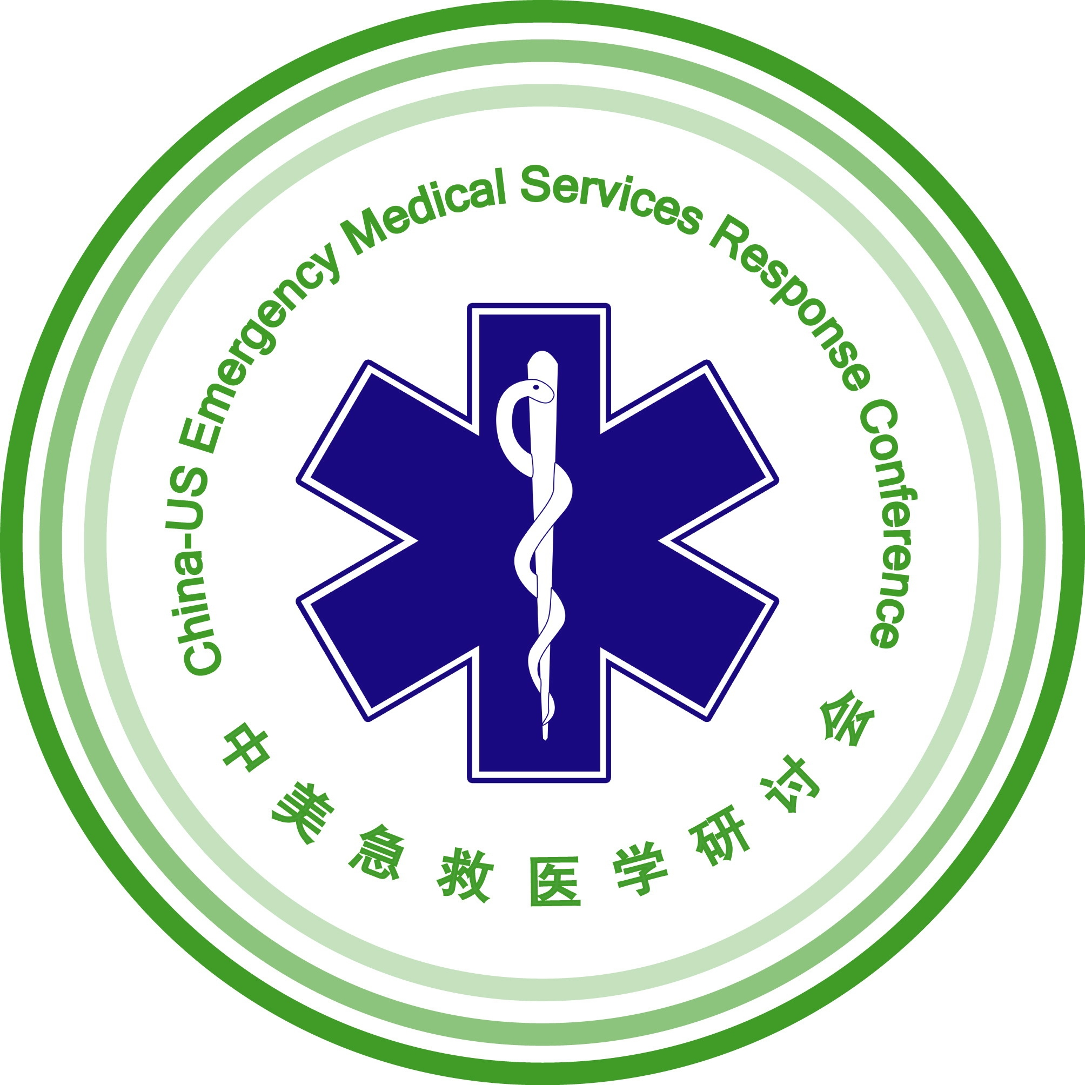

CALL FOR PAPERS
CHINA – U.S. CONFERENCE
EMERGENCY MEDICAL SERVICES IN DISASTER MANAGEMENT
Beijing, CHINA

September 15-18, 2009
9-Day Conference and Study Program
September 9-19, 2009

The Conference format will include keynote and featured speakers, as well as presenters for breakout sessions. Breakout sessions will be 90 minute interactive sessions. The session will feature both a Chinese and U.S. or international speaker. Presentations should be designed to generate a conversation with the audience around the presentation topic. The speaker will present a 15-minute presentation (requiring a total of 30 minutes including interpretation), followed by the second speaker. An interactive discussion will be facilitated after both presentations have been heard to distinguish the similarities and differences between the approaches, policies, or practices. All participants are required to participate fully in the four days of the Conference. Each presenter much submit a full paper for the interpreter.

Submitting a Proposal
All submissions must address the Symposium topics listed below. Submissions must include 3 documents:
1) 250 word abstract,
2) The major points of the presentation and the outcomes the participate can expect from participating in the session,
3) 1 page biographical sketch, not to exceed 250 words.
**Formats for these documents and transmission instructions can be found below and at www.globalinteractions.org

SUGGESTED TOPICS

Planning and Preparation Special Needs Populations
Mass Gatherings Incident Management Systems
Bio Surveillance Surge Capacity
Personal Safety of Providers Mass Decontamination
Natural Disasters Training Topics
Chemical, Biological, Radiation, Nuclear and Explosives Urban Search & Rescue/Disaster Medical Assistance Teams

DEADLINE FOR SUBMISSION is April 6, 2009. Selected presenters will be notified by April 17 and must register with a $600.00 deposit by May 8 to insure inclusion on the Symposium program. All presenters must submit full papers of their presentation for translators by July 20. Submit all items by e-mail attachment to info@globalinteractions.org. Use Times New Roman 12 pt font. All submissions will be acknowledged. Submissions will not be returned.
Presenters are invited to attend the 9-Day Program beginning September 9. All participants must arrive in Beijing by September 13 and remain through the close of the Conference on September 18.

Global Interactions, 14 West Cheryl Drive, Phoenix, AZ 85021 Phone: 602.906.8886 e-mail: info@globalinteractions.org

_____ DISCOVERING OUR LIFE PATH _____ EXPRESSING YOUR LEADERSHIP
CALL FOR SYMPOSIUM PRESENTATIONS
CHINA – U.S. EMERGENCY MEDICAL SERVICES CONFERENCE

NAME __________________________________________________________________ (aS IT APPEARS ON YOUR PASSPORT)
TITLe _______________________________________________________________Academic Degree_____________________
cOMPANY OR iNSTITUTEION__________________________________________________________________________________
preferred mailing Address _______________________________________________________________________________
City______________________________________________________________________STATE__________ZIP________________
PHONE(s) office____________________________cell___________________________FAX_____________________________
E-MAIL________________________________________________________________________________________________________
SYMPOSIUM TOPICS
Check the area(s) your presentation will address. Select no more than 3

___ Response Time ___ Special Needs ___ Environmental Treat
___ EMS at Mass Gatherings ___ USAR Topics ___ Mass Decontamination
___ Bio Surveillance and EMS ___ Incident Command System ___ Surge Capacity
___ Pediatrics ___ Personal Safety of Providers ___ EMS Primary Care
___ Planning and Exercises ___ EMS Training Topics ___ Chemical, Biological, Radiation,
Nuclear and Explosives
PREENTATION TITLE ___________________________________________________________________________________________

Write a 250 word abstract on one of the topics above and attach to this submission.

Global Interactions, 14 West Cheryl Drive, Phoenix, AZ 85021 Phone: 602.906.8886 e-mail: info@globalinteractions.org

Pag e 2

CALL FOR PAPERS
CHINA – U.S. EMERGENCY MEDICAL SERVICES CONFERENCE
Presentation Summary

presenter’s name ____________________________________________________________________________________________

presentation Title __________________________________________________________________________________________
major Points:

PARTICIPANT OUTCOMES:

Global Interactions, 14 West Cheryl Drive, Phoenix, AZ 85021 Phone: 602.906.8886 e-mail: info@globalinteractions.org

PAGE 3

CALL FOR PAPERS
CHINA – U.S. EMERGENCY MEDICAL SERVICES CONFERENCE

BIOGraphical Sketch

Name _____________________________________________________________________________________________

PRESENTATION TITLE _____________________________________________________________________________

Provide a biographical sketch of your credentials and experience related to your presentation.

Global Interactions, 14 West Cheryl Drive, Phoenix, AZ 85021 Phone: 602.906.8886 e-mail: info@globalinteractions.org

PAGE 4

